RAJAN PANWAR
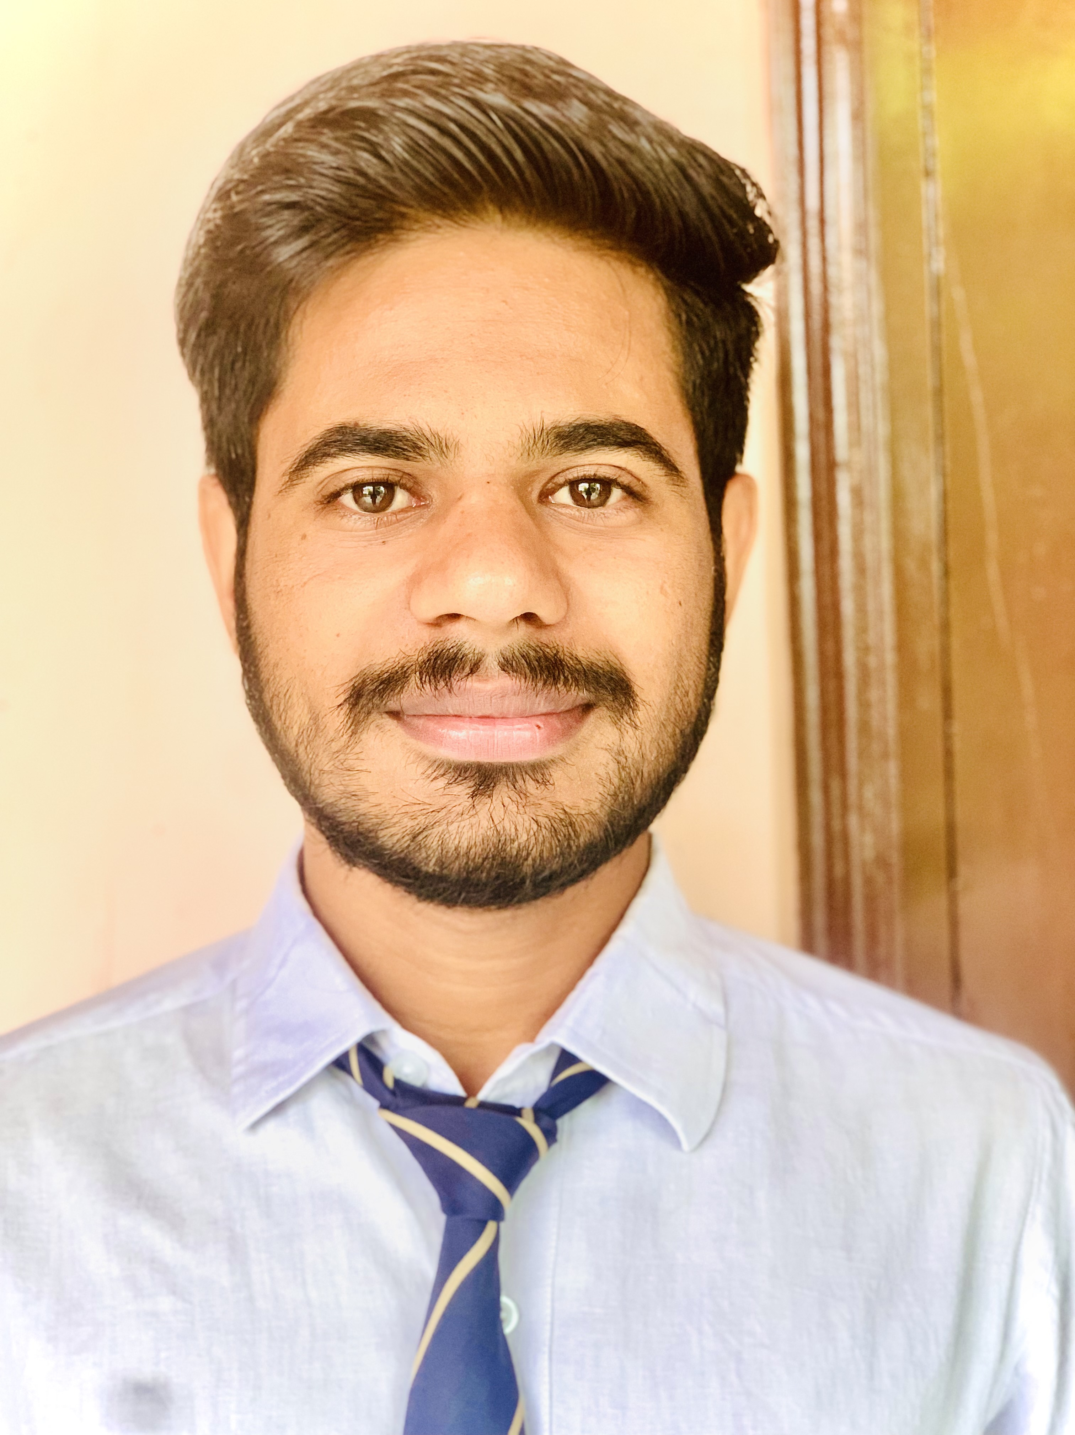
E-mail- rajanrajneesh1606@gmail.com
Ph No: +91 7088665206
Vill+Post – Nalhera gujjar
Saharanpur, Uttar Pradesh-247341
______________________________________________
Objective: Seeking a challenging position in your esteemed organization where my co-ordination skills can be effectively utilized to improve operations and contribute to the company’s growth.

Educational Qualification:

- Completed Class 12 From JAWAHAR NAVODAYA VIDYALAYA
- Passed Class 10 from JAWAHAR NAVODAYA VIDYALAYA

SOFT SKILLS:

- Basic in computers
- Good Communication Skills

Personal Skills:

- Good verbal and written communication skills
- Ability to work hard
- Ability to build motivation
- Creative & self-confident
- Positive approach thinking

PERSONAL DETAILS:
Father’s Name : Mr Krishna pal
Mother’s Name : Mrs Ravita devi
Date of birth : 13 Oct 2002
Sex : Male
Nationality : Indian

DECLARATION :

The above-mentioned information is true and correct to the best of my knowledge and belief. If I am selected and given a chance to serve in your esteemed organization, I shall prove my best and ability to the entire satisfaction of my superiors.

yours faithfully
RAJAN PANWAR

